**Program 1**

06/05/2021

**Aim:** Program to Sort strings.

**Source Code:**

**package** packoops;

**import** java.util.Scanner;

**public** **class** stringsort {

**public** **static** **void** main(String[] args) {

**int** count;

String string;

Scanner s=**new** Scanner(System.***in***);

System.***out***.println("Enter the number of strings: ");

count=s.nextInt();

String str_arr[]=**new** String[count];

Scanner sc=**new** Scanner(System.***in***);

System.***out***.println("Enter the strings: ");

**for**(**int** i=0;i<count;i++)

{

str_arr[i]=sc.nextLine();

}

s.close();

sc.close();

**for**(**int** i=0;i<count;i++)

{

**for**(**int** j=i+1;j<count;j++)

{

**if**(str_arr[i].compareTo(str_arr[j])>0)

{

string=str_arr[i];

str_arr[i]=str_arr[j];

str_arr[j]=string;

}

}

}

System.***out***.println("String after sorting: ");

**for**(**int** i=0;i<count;i++)

{

System.***out***.print(str_arr[i]+",");

}

}

}

**Output:**

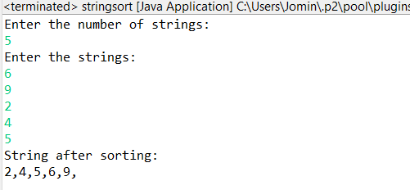

**Program 2**

07/05/2021

**Aim:** Search an element in an array.

**Source Code:**

**package** packoops;

**import** java.util.Scanner;

**public** **class** searchelement

{

**public** **static** **void** main(String[] args)

{

**int** n, x, flag = 0, i = 0;

Scanner s = **new** Scanner(System.***in***);

System.***out***.print("Enter number of elements:");

n = s.nextInt();

**int** a[] = **new** **int**[n];

System.***out***.println("Enter the elements:");

**for**(i = 0; i < n; i++)

{

a[i] = s.nextInt();

}

System.***out***.print("Enter the element to be searched:");

x = s.nextInt();

**for**(i = 0; i < n; i++)

{

**if**(a[i] == x)

{

flag = 1;

**break**;

}

**else**

{

flag = 0;

}

}

**if**(flag == 1)

{

System.***out***.println("Element found");

}

**else**

{

System.***out***.println("Element not found");

}

}

}

**Output:**

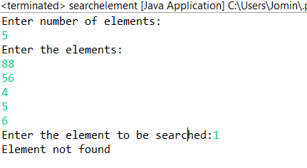

**Program 3**

10/05/2021

**Aim:** Perform string manipulations

**Source Code:**

**package** packoops;

**import** java.util.Scanner;

**public** **class** stringhandling {

**public** **static** **void** main(String[] args)

{

Scanner s=**new** Scanner(System.***in***);

System.***out***.println("Enter the first strings: ");

String s1=s.nextLine();

System.***out***.println("Enter the Second strings: ");

String s2=s.nextLine();

System.***out***.println("Enter the Third strings: ");

String s3=s.nextLine();

System.***out***.println("Enter the Fourth strings: ");

String s4=s.nextLine(); ;

System.***out***.println("String 1:"+s1);

System.***out***.println("String 2:"+s2);

System.***out***.println("String concatenation:"+s1.concat(s2));

System.***out***.println("String length of first string:"+s1.length());

System.***out***.println("String comparison of two strings:"+s1.compareTo(s2));

System.***out***.println("String 2 empty or not:"+s2.isEmpty());

System.***out***.println("String 3 empty or not:"+s3.isEmpty());

System.***out***.println("Before trimming:"+s4);

System.***out***.println("After String trim:"+s4.trim());

System.***out***.println("String toLowerCase():"+s1.toLowerCase());

System.***out***.println("String toUpperCase():"+s2.toUpperCase());

System.***out***.println("String replace():"+(s1.replace("H", "B")));

System.***out***.println("Character Position value:"+s2.charAt(0));

System.***out***.println("String equals():"+s1.equals(s2));

}

}

**Output:**

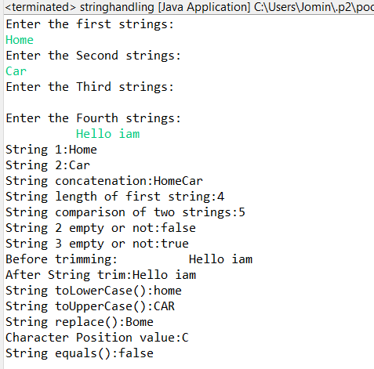

**Program 4**

20/05/2021

**Aim:** Program to create a class for Employee having

attributes eNo, eName eSalary. Read n employ

information and Search for an employee given eNo,

using the concept of Array of Objects.

**Source Code:**

**package** packoops;

**import** java.util.Scanner;

**public** **class** employee {

**int** eNo;

String eName;

**int** salary;

employee(**int** a, String b,**int** c) {

eNo=a;

eName=b;

salary=c;

}

**public** **void** display(**int** p)

{

**if**(p==eNo) {

System.***out***.println("Employee number : " + eNo +"\n"+ "Employee Name : " +eName + "\n"+ "Salary : " +salary);

}

}

**public** **static** **void** main(String[] args)

{ **int** a;

**int** b;

**int** s;

String c;

Scanner obq=**new** Scanner(System.***in***);

Scanner obq1=**new** Scanner(System.***in***);

System.***out***.println("Enter the number of employee :");

a=obq.nextInt();

employee[] obj=**new** employee[a];

**for**(**int** i=0;i<a;i++)

{

System.***out***.println("Enter the employee N.O :");

b=obq.nextInt();

System.***out***.println("Enter the employee Name :");

c=obq1.nextLine();

System.***out***.println("Enter the employee Salary :");

s=obq.nextInt();

obj[i]=**new** employee(b,c,s);

}

System.***out***.println("Enter the emp number :");

**int** t=obq.nextInt();

**for**(**int** j=0;j<a;j++)

{

obj[j].display(t);

}

}

}

**Output:**

